**Section 2–8B: Absolute Value Inequalities**

You can graph two-variable absolute value inequalities in the same way that you graph linear inequalities.

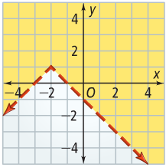**Example 1: Graphing an Absolute Value Inequality**

What is the graph of $1-y<\left|x+2\right|$?

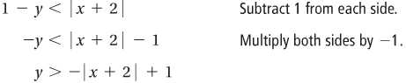

**\*\***

**\*\*You should remember to flip the sign when multiply or divide with a negative value!!**

The graph of $y=-\left|x+2\right|+1$ is the graph of $y=\left|x\right|$, reflected in the *x*-axis and translated left 2 units and up 1 unit.

Since the inequality is solved for $y$ and $y>-\left|x+2\right|+1$, shade the region above the boundary.

**Example 2: Writing an Inequality Based on a Graph**

What inequality does this graph represent?

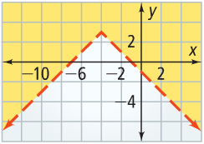

The boundary is the graph of the absolute value function $y=\left|x\right|$, translated. The vertex of $y=\left|x\right|$ is translated to $(-4, 3)$**\*\***, so the boundary is the graph of $y=\left|x+4\right|+3$.

**\*\*you should always look at the scale of the graph!!**

The solution is shaded above the boundary, so the inequality is either $>$ or $≥$. Since the boundary is a dashed line, the correct inequality is $y>-\left|x+4\right|+3$.